REMINC/CONTI
POWERLOK® iI™ Fasteners
END-USER SPECIFICATIONS

REMINC/CONTI
POWERLOK® II™ FASTENERS
end-user specifications

introduction
This document provides end-users of POWERLOK® II™ fasteners dimensional and material information to be used as a uniform standard for POWERLOK® II™ fasteners. End-users may use this copyrighted material to create their own in-house POWERLOK® II™ fastener standards. This information is intended for use only with genuine POWERLOK® II™ products and prior notification to and permission from REMINC/CONTI is required before incorporating this copyrighted material into any company documents.

scope
- POWERLOK® II™ Fasteners screws are prevailing torque fasteners that provide resistance to loosening from vibrational forces, thermal cycling or other alternating loads in threaded nut members or nuts. POWERLOK® II™ fasteners often eliminate the need for lock washers, adhesives or patches, lowering the
in-place cost of assembly.
- POWERLOK® II™ Fasteners have a special dual-angle thread form to provide interference in standard 6H (metric) or 2B (inch) internal threads. POWERLOK® II™ Fasteners are available in two general configurations; The tapered lead threads may be sharp or underfilled crests to provide ease of hand starting into a nut member. The prevailing torque performance of the fastener is unaffected and the choice for sharp or underfilled threads should be left to the fastener manufacturer, as the part configuration will determine the manufacturing sequence and point configuration.
- The heat treatment for POWERLOK® II™ fasteners, referred to as CORFLEX®-‘N’, is a slightly modified neutral hardened heat treatment.
- POWERLOK® II™ fasteners can be supplied with standard coatings and lubricants.

POWERLOK® II™ FASTENERS Metric Standards Sizes M2-M12

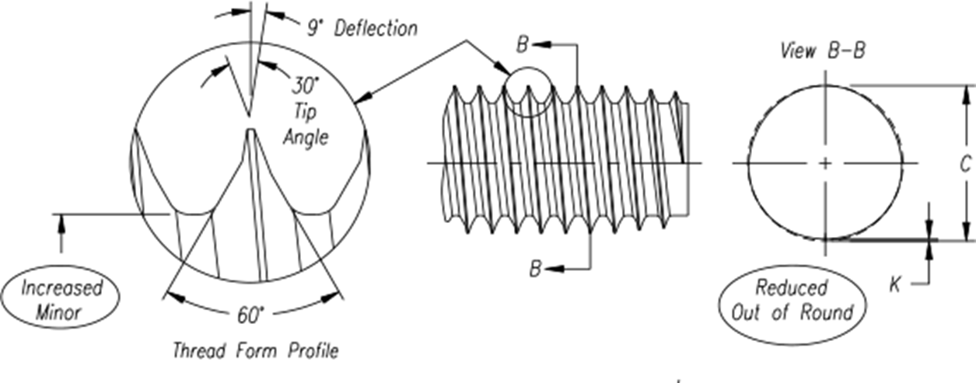

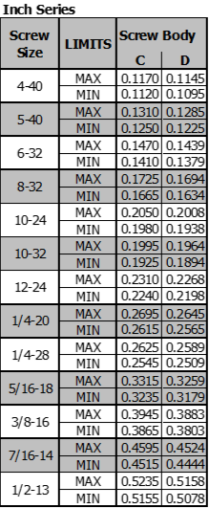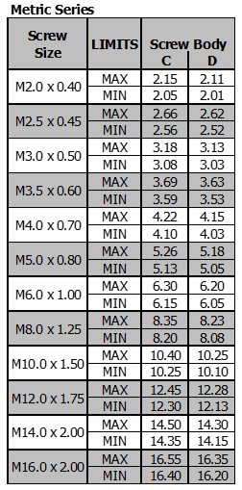

Note: Dimensions for smaller, larger or fine thread pitches available from REMINC/CONTI

POWERLOK® II™ FASTENERS CORFLEX®-‘N’ Neutral Hardened

Material, Mechanical & Performance Requirements

- SCOPE

  - This section specifies the requirements for CORFLEX®-‘N’ neutral hardened POWERLOK® II™ fasteners intended for use in steel. The requirements stated are intended to qualify POWERLOK® II™ fasteners as meeting their intended requirements and are not associated with specific applications.

  - REFERENCES:
ISO-898/1 Mechanical Properties
ISO-6507 Hardness Test – Vickers Test

- MATERIALS

  - Cold heading quality fully killed steel wire. Material shall conform to the following check analysis chemical composition limits.

Carbon | 0.13 – 0.30
Manganese | 0.54 – 1.81
Sulfur | 0.045 Maximum
Phosphorous | 0.035 Maximum
Silicon | 0.10 Maximum
Boron | 0.0005 – 0.002 (Optional)

- MECHANICAL PROPERTIES

  - REFERENCES:
ISO-898/1 Mechanical Properties with the following exceptions
      - Screws produced to this standard possess mechanical properties in line with ISO 898/1 property classes 8.8, 9.8 and 10.9.
      - Since decarburization on CORFLEX®-‘N’ heat treated POWERLOK® II™ fasteners could result in thread breakdown, depending on nut hardness, decarburization as permitted by ISO 898/1 is replaced in this standard by a requirement for carbon restoration.

TAPTITE 2000® SCREWS CORFLEX®-‘N’ Neutral (Through) Hardened

Material, Mechanical & Performance Requirements

- MATERIAL

Cold heading quality fully killed carbon steel.

Carbon steel with additives i.e. boron, manganese or chrome, can be used. To conform to ISO-898/1.

Carbon Steel - Check analysis composition - % by weight
Carbon | 0.25 – 0.55
Phosphorous | 0.035 Maximum
Sulfur | 0.035 Maximum

Carbon Steel with Additives - % by weight
Carbon | 0.15 – 0.40
Phosphorous | 0.035 Maximum
Sulfur | 0.035 Maximum

In the case of boron alloyed steel with a carbon content below 0.25%, the minimum manganese content shall be 0.60%.

  - Heat Treatment
Screws are to be neutral (through) hardened in a continuous non-carburizing furnace using fine grain practices. Furnace atmosphere must be controlled to maintain decarburization restrictions as specified in Section 3.2 and surface hardness conditions as specified in Section 3.3.
Quenching medium to suit selected material, suitable to create a martensitic microstructure.
Minimum tempering temperatures relative to grade strength of the hardness level desired. The standard core hardness is in accordance with PC 10.9, (HRC 33-39 / HV 330-390) but 8.8, 9.8 or 12.9 could be used in certain applications. should follow that specified in ISO 898/1.

  - Wedge Tensile
Screws shall meet wedge tensile breaking loads as specified in ISO-898/1 for the applicable equivalent property class (8.8, 9.8, 10.9).
Screws not having suitable head styles (i.e. countersunk heads) are exempt from this test. Screws with lengths shorter than 13mm or have a length less than three times the nominal screw diameter are also exempt.

  - Decarburization
During the hardening process the carbon potential of the atmosphere shall be maintained at a level between “zero” (0) decarburization to slightly in excess of the carbon content of the screws being processed. This process of carbon restoration is designed to eliminate partial and total decarburization of the screw thread form. Partial or complete decarburization of the screw thread form would seriously impair the thread rolling properties of the screw.
Carbon enrichment up to 0.1mm maximum from the surface of the screw is permitted as a result of the carbon restoration process.

  - Surface Hardness
The surface hardness shall not be more than 30 Vickers points above the measured core hardness on the product when readings of both surface and core are carried out.

- TEST METHODS

  - Decarburization Test
Longitudinal sections shall be taken through the thread axis approximately one nominal diameter from the end of the screw. The specimen shall be suitably mounted and prepared for metallographic examination at not less than 100 x magnification. Prior to examination the sample shall be etched in Nital solution.

  - Surface Hardness Test
The surface hardness shall be measured using the Vickers Hardness Testing Procedure in accordance with ISO 6507.

The surface hardness shall be performed on the head after removal of any finish and suitable preparation (1200 grit grinding or better). Care should be taken to remove as little material as possible.
For referee purposes, a micro-hardness instrument with a Vickers indenter and a 300g load shall be used. In such cases, measurements shall be made on the thread profile of a suitably prepared longitudinal metallographic specimen.

- MARKING

  - Trade (Identification) Marks
The trade (identification) marks of the manufacturer is mandatory on all products, which can be marked with manufacturers’ symbol.

- SURFACE DISCONTINUITIES

  - The application of surface discontinuity specifications is per agreement between manufacturer and end user customer. Regardless of the agreed upon specification, spec parameters should not be applicable to point threads and thread forming threads.

- EMBRITTLEMENT

The issue of embrittlement is relative to the property class and finish/coating ordered and is to be determined by agreement between manufacturer and end user customer.

